Joshua Wooi  
ENGL 150 - Assignment 3 (Revised)  
December 11th, 2018  
Dr. Ben Larson

Society of International Engineers

A land grant university is an institution of higher education supported by a state and focuses on the teachings of practical subjects. When Iowa State University opened its doors in 1869, it was recognized as the first coeducational land-grant institution (“History”). The mission and vision of Iowa State U is as follows, “create, share, and apply knowledge to make Iowa and the world a better place” (“Mission”). In amongst other equally crucial factors, this will only be possible through the communication and collaboration between a diverse group of individuals, hailing from different backgrounds, beliefs, and the ideas that they can contribute. The Society of International Engineers closely follows these principles and reflects the ideals of Iowa State University as a land-grant university.

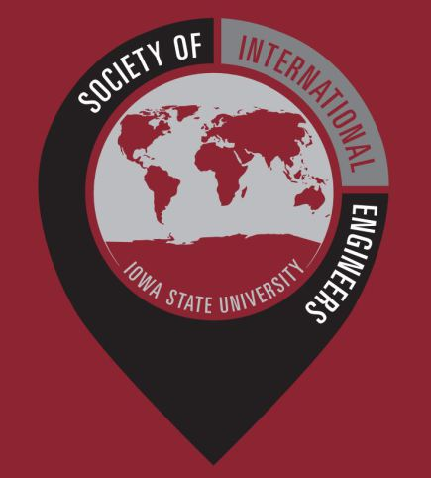The Society of International Engineers, often abbreviated as SIE, is a group of engineering students at Iowa State University looking to build a strong community of international engineers on campus (“About”). The society welcomes and represents both American and international students from all parts of the world and offers a gathering place for these students to bond and form friendships during events and general meetings (“Events”). As the world gets smaller, these bonds and friendships encourage contact between cultures in a peaceful manner, and this allows for more creative and innovative banter in a global scale (“Intercultural Communication”). As recently as September 23rd, SIE held an American Flag Football Event to introduce new international members of SIE to the staple sport of American culture. The ultimate purpose of these events is to provide hospitality to international students in the College of Engineering (“Student Organizations”).

Society of International Engineers logo

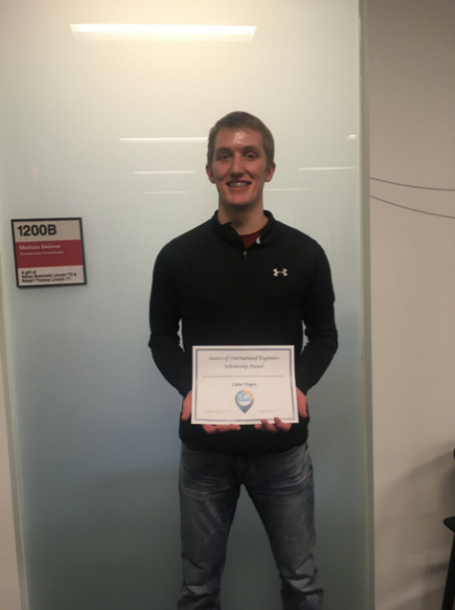SIE has three main objectives; to promote the study abroad program, to welcome returning ISU students from abroad, and to welcome international students to Iowa State University (“About”). The study abroad program provides generous aids to ISU students in their endeavors to study abroad in the form of scholarships. These scholarships are awarded in the spring and fall semesters to engineering students, and through a fair and systematic selection process that prioritizes grades and duration of study (“Scholarships”). Recipients of said scholarships usually spend a semester in a foreign institution abroad and are expected to be active members in the society, and share their experiences with others when they return (“Scholarships”). Leading positions in SIE are largely held by students with such experiences, with the President of SIE, Christopher Holloway, spending six weeks in Brunel University London, and the Financial Chair of SIE, Kaelyn Swetala, studying in New Zealand (“Cabinet”). Carter Engen was the 2017 scholarship recipient and he studied a semester at the University of Limerick, Ireland (“Scholarships”).

Carter Engen

It stands to reason that studying abroad and having international education experiences would come with its many benefits. It allows for students to develop applicable proficiencies in the job market, and it expands their worldviews on the working life of other cultures (“Benefits”). Qualities employers look for when considering new recruits are directly tied with qualities gained with experiences abroad, and that includes intercultural competencies in a workspace environment (“Benefits”). These qualities tend to stand out on a resume, and this is supported by a study that claims upwards of 64 percent of employers consider study abroad experience to be important (“Eramus”). These benefits should stand on their own as an incentive to consider studying abroad, but it also allows for personal growth. Putting oneself out in a seemingly intimidating and unfamiliar environment encourages independence and adaptability, and more often than not, the challenges that one goes through can only make them a more mature person (“Study Abroad”).

In short, the Society of International Engineers emphasizes on practical teachings to everyone, and only strives to assist ISU students to succeed in life. Their mission and vision are constantly indicated in their actions for the institution, and their establishment leads to the betterment of Iowa State University as a land-grant university.

Works Cited

“History” - <https://web.iastate.edu/about/history>, accessed September 22nd, 2018

“Mission” - <https://www.president.iastate.edu/projects/mission>, accessed September 22nd, 2018

“About” - https://iastatesie.wordpress.com/about/, accessed September 22nd, 2018

“Events” - <https://iastatesie.wordpress.com/events/>, September 26th, 2018

“Student Organizations” - [https://www.engineering.iastate.edu/studyabroad/sample- page/student-organizations/](https://www.engineering.iastate.edu/studyabroad/sample-%20%09%09%09page/student-organizations/), accessed September 22nd, 2018

“Scholarships” - <https://iastatesie.wordpress.com/scholarship/>, accessed September 22nd, 2018

“Cabinet” - <https://iastatesie.wordpress.com/cabinet/>, accessed September 22nd, 2018

“Benefits” - https://agsci.psu.edu/international/study-abroad/benefits-of-study-abroad, accessed September 26th, 2018

“Study Abroad” - <https://www.northeastern.edu/graduate/blog/study-abroad-benefits/>, accessed September 26th, 2018

“Eramus” ­- https://esn.org/erasmus-impact-study, accessed September 26th, 2018

“Intercultural Communication” - [https://mkbconseil.ch/intercultural-communication-important- know-summary-interview-dr-milton-bennett/](https://mkbconseil.ch/intercultural-communication-important-%20%20%20%20%20%20%09know-summary-interview-dr-milton-bennett/), accessed December 12th, 2018