Society of International Engineers
In broad strokes, a land grant university is an institution of higher education supported by a state, which focuses on the teachings of practical subjects. When Iowa State U opened its doors in 1869, it was recognized as the very first coeducational land-grant institution (“History”), and the mission and vision of Iowa State U is as follows, “create, share, and apply knowledge to make Iowa and the world a better place.” (“Mission”) In amongst other equally crucial factors, this will only be possible through the communication and collaboration between a diverse group of individuals, hailing from different backgrounds, beliefs, and crucially—ideas. The purpose of this paper is to demonstrate that the Society of International Engineers reflects the principles of Iowa State U as a land-grant university.
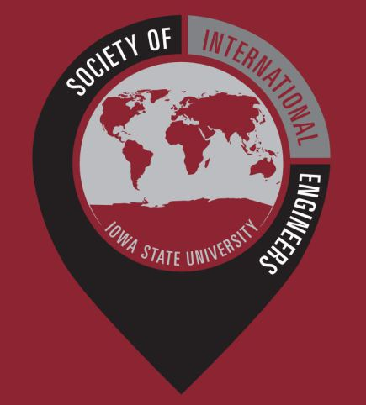
The Society of International Engineers, often abbreviated as SIE, is a group of engineering students at Iowa State University looking to build a strong community of international engineers (“About”). The society welcomes and represents both international and American students from all parts of the world, and provides a gathering place for engineering students to bond and form friendships during events and general meetings (“Events”). Very recently, SIE held an American Flag Football Event on September 23rd to introduce new international members of SIE to American football. The ultimate purpose of these events is to provide hospitality to international exchange or transfer students in the College of Engineering (“Student Organizations”).
Society of International Engineers logo
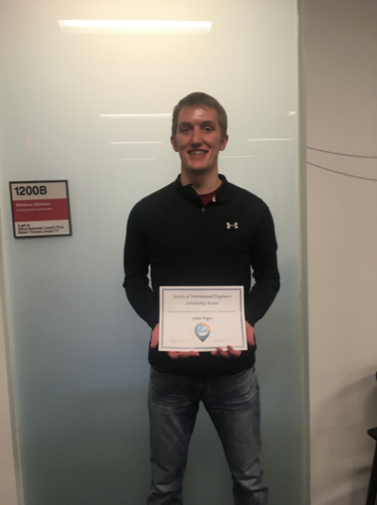
SIE has three main objectives; to promote the study abroad program, to welcome returning ISU students from studying abroad, and to welcome international students to Iowa State University (“About”). The study abroad program is a program that provides financial aids to ISU students in their ventures to study abroad. These scholarships are awarded in the spring and fall semesters to engineering students, and this is done so, through a fair and systematic selection process that prioritizes grades and duration of study (“Scholarships”). Recipients of said scholarships usually get to study a semester abroad, and when they return, are expected to be active members in the society, and share their experiences with others (“Scholarships”). Leading positions in SIE are mostly held by students with such experiences, with the President of SIE, Christopher Holloway, spending six weeks in Brunel University London, and the Financial Chair of SIE, Kaelyn Swetala, studying in New Zealand (“Cabinet”). Carter Engen was the 2017 scholarship recipient and he studied a semester at the University of Limerick, Ireland (“Scholarships”).
Carter Engen
So, why should students consider joining the program? Studying abroad and having international education experiences undoubtedly comes with its many benefits. It allows for students to develop valuable proficiencies to succeed in the job market, and it expands on their worldviews (“Benefits”). Qualities employers look for when considering new recruits are directly tied with qualities gained with experiences abroad, and that includes intercultural competencies in a workspace environment (“Benefits”). These qualities tend to stand out on a resume, and according to a study, upwards of 64 percent of employers consider study abroad experience to be important (“Eramus”). These benefits should stand on their own as an incentive to consider studying abroad, but it also allows for personal growth. Putting oneself out in a seemingly intimidating and unfamiliar environment encourages independence and adaptability, and more often than not, the challenges that one goes through can only make them a more mature person (“Study Abroad”).
In short, the Society of International Engineers emphasizes on practical teachings to everyone, and only strives to assist ISU students to succeed in life.

Citations
“History” - https://web.iastate.edu/about/history, accessed September 22nd, 2018
“Mission” - https://www.president.iastate.edu/projects/mission, accessed September 22nd, 2018
“About” - https://iastatesie.wordpress.com/about/, accessed September 22nd, 2018
“Events” - https://iastatesie.wordpress.com/events/, September 26th, 2018
“Student Organizations” - https://www.engineering.iastate.edu/studyabroad/sample-page/student-organizations/, accessed September 22nd, 2018
“Scholarships” - https://iastatesie.wordpress.com/scholarship/, accessed September 22nd, 2018
“Cabinet” - https://iastatesie.wordpress.com/cabinet/, accessed September 22nd, 2018
“Benefits” - https://agsci.psu.edu/international/study-abroad/benefits-of-study-abroad, accessed September 26th, 2018
“Study Abroad” - https://www.northeastern.edu/graduate/blog/study-abroad-benefits/, accessed September 26th, 2018
“Eramus” - https://esn.org/erasmus-impact-study, accessed September 26th, 2018

