Joshua Wooi
ENGL 150 - Assignment 4
The Zodiac
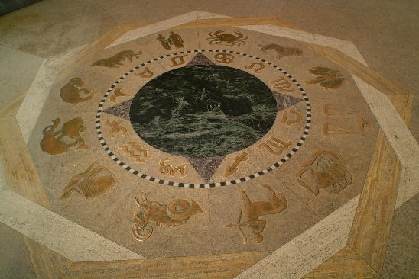
An artifact, as defined by Merriam-Webster, is “something characteristic of or resulting from a particular human institution, period, trend, or individual” “Definition”. Iowa State University, an institution established since 1869, recognizes the importance of historical and meaningful artifacts to an open society, and therefore, maintains an abundance of such artifacts all around campus. One such example, is the art piece often simply referred to as ‘The Zodiac’. This paper hopes to explore on the history, importance, and significance of ‘The Zodiac’ to Iowa State University.
The Zodiac
The Zodiac is the first thing a visitor would come by when they first step into the Memorial Union building. Embedded into the ground at the center of the entrance space, it is a relatively circular relief sculpture mostly made of bronze and stone, and the major iconography found on the Zodiac are of the symbols and characters of its namesake. Designed by architect and designer, William T. Proudfoot, the Zodiac was constructed with the intent of incorporating ancient Greek and Roman origins to reflect the Memorial Union building, which was a building built with Greek and Roman influences ‘The Zodiac’. The use of bronze and stone was also by design, as the ancient Greeks and Romans prominently made statuaries out of bronze, further emphasizing the influence of the era ‘Bronze in ancient Greece’. Soon after Proudfoot had the logistical aspect of the building process finalized, the Memorial Union and the Zodiac was constructed and opened to the public by September of 1928 ‘The Zodiac’.
What makes the Zodiac significant to Iowa State U is the tradition associated with it. By 1929, Iowa State U students begun to notice that the symbols of the Zodiac—which were made of bronze—were showing signs of wear because of the footsteps of the hundreds and thousands of visitors to the Memorial Union. These students had grown fond of the Zodiac, or rather, the three-dimensional effect of the sculpture, and decided to start a rumor. As it were, the rumor stated that should any student step on the Zodiac, they would be struck with bad luck and fail on their next test or exam. ‘The Zodiac’. The rumor spread around campus and, in time, was recognized and implemented as an Iowa State U tradition. Even the most skeptical hedge their bets, and it is now common practice to walk on the carpeted path around the Zodiac. It is because of this tradition, that at nearly a century old, the Zodiac remains relatively well-preserved. And it is now acknowledged as one of, if not the most, renowned traditions of Iowa State U ‘Tradition’.
It has been said, that Proudfoot had initial plans for the intentional wearing away of the bronze until it was level to the floor over time, which has since been contradicted by the implementation of this tradition ‘Zodiac’. However, if Proudfoot had intended for the Zodiac to ultimately be flat to the ground, why would he go through the trouble of making it a relief sculpture? Perhaps he had intended to incorporate the involvement of the students in the creation process of the Zodiac. And perhaps, should the Zodiac eventually be worn to the ground, and thus fulfilling the vision Proudfoot had for the art piece, the Zodiac could be declared as a collaborative effort between Proudfoot and the many generations of Iowa State U students after him.
The Zodiac is an important aspect of Iowa State U because it holds a significant tradition to the students of Iowa State U. Tradition, absurd as some may be at times, plays an important part in human relationships and personal interactions. What makes something a tradition is that it is handed down from one generation to the next, creating a link between generations, and ultimately, encourages the development of civilized societies. It is the means to an end, which is why it must be honored and respected ‘Importance of Tradition’.

Works Cited
‘Definition’ https://www.merriam-webster.com/dictionary/artifact, accessed on October 7th, 2018.
‘History’ https://web.iastate.edu/about/history, accessed on October 7th, 2018.
‘Zodiac’ https://www.foundation.iastate.edu/s/1463/giving/interior.aspx?sid=1463&gid=1&pgid= 252&cid=4352&ecid=4352&crid=0&calpgid=1284&calcid=4346, accessed on October 14th, 2018
‘Traditions’ https://www.mu.iastate.edu/about/traditions-myths--stories, accessed on October 14th, 2018
‘Bronze in ancient Greece’ https://www.metmuseum.org/toah/hd/grbr/hd_grbr.htm, accessed on October 30th, 2018
‘Importance of Tradition’ https://www.psychalive.org/importance-tradition/, accessed on October 30th, 2018

